### **Networking Project 2**

### 

### **Mission 1**

**Determine and document the mail servers for starwars.com using NSLOOKUP.**  
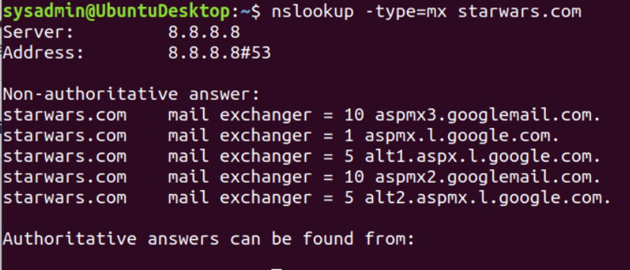

**Explain why the Resistance isn't receiving any emails.**

The reason the Resistance isn’t receiving any emails is because an intruder has changed the primary and secondary mail servers. The correct primary and secondary mail servers should be: asltx.1.google.com and asltx.2.google.com

**Document what a corrected DNS record should be.**

The correct DNS record should be:

starwars.com mail exchanger = 1 asltx.1.google.com.

starwars.com mail exchanger = 5 asltx.2.google.com.

### **Mission 2**

**Determine and document the SPF for theforce.net using NSLOOKUP**.

theforce.net text = "v=spf1 a mx mx:smtp.secureserver.net include:aspmx.googlemail.com ip4:104.156.250.80 ip4:45.63.15.159 ip4:45.63.4.215"

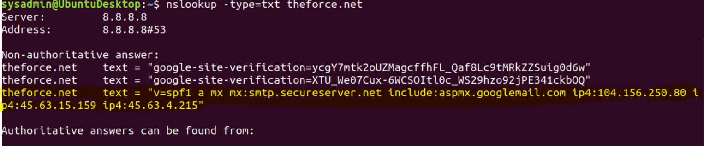

**Explain why the Force's emails are going to spam.**

While the network was down The Force changed their IP address mail server to 45.23.176.21 and it is not matching the SPF record.  
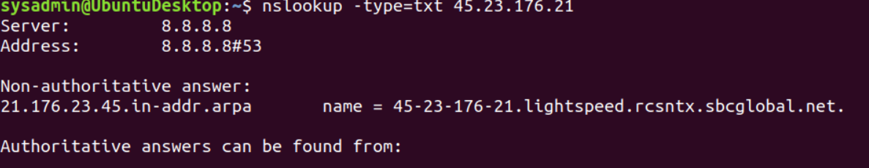

**Document what a corrected DNS record should be.**

The correct DNS record should include IP address 45.23.176.21

### 

### 

### 

### 

### 

### 

### **Mission 3**

**Document how a CNAME should look by viewing the CNAME of www.theforce.net using NSLOOKUP.**

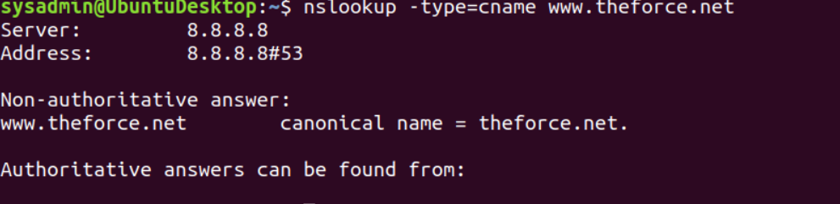

**Explain why the sub page of resistance.theforce.net isn't redirecting to theforce.net.**

The CNAME is missing a reference to direct “resistance.theforce.net” to “theforce.net”.

**Document what a corrected DNS record should be.**

The correct DNS record should be: www.resistance.theforce.net

### **Mission 4**

**Confirm the DNS records for princessleia.site**.  
The DNS record for princessleia.site does not have ns2.galaxybackup.com listed as a nameserver.

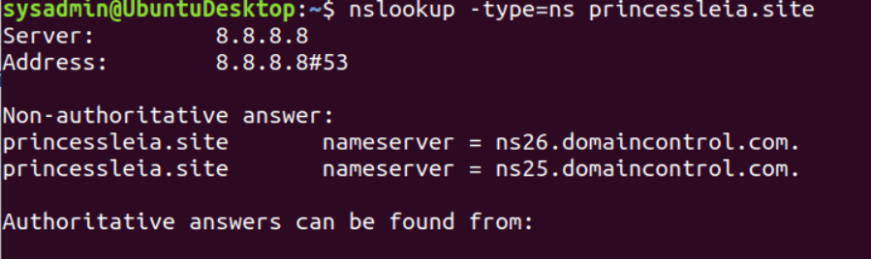

**Document how you would fix the DNS record to prevent this issue from happening again.**

To prevent this issue from happening again ns2.galaxybackup.com should be added as a nameserver.

Non-authoritative answer:

princessleia.site nameserver = ns26.domaincontrol.com.

princessleia.site nameserver = ns25.domaincontrol.com.

princessleia.site nameserver = ns2.galaxybackup.com.

**Mission 5**

**View the Galaxy Network Map and determine the OSPF shortest path from Batuu to Jedha**.

Batuu-D-C-E-F-J-I-L-Q-T-V-Jedha

**Confirm your path doesn't include Planet N in its route**.

The route does not include “N”.

**Document this shortest path so it can be used by the Resistance to develop a static route to improve the traffic**.

Batuu-D-C-E-F-J-I-L-Q-T-V-Jedha

1-2-1-1-1-1-6-4-2-2-2 = 23 hops.

### **Mission 6**

**Figure out the Dark Side's secret wireless key by using Aircrack-ng.**

aircrack-ng -w /usr/share/wordlists/rockyou.txt Darkside.pcap

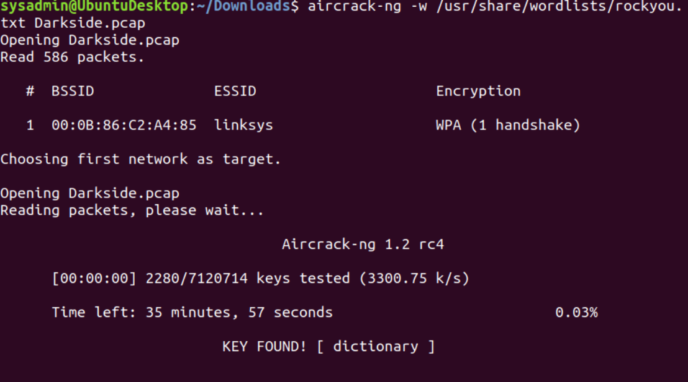

**Hint: This is a more challenging encrypted wireless traffic using WPA.  
In order to decrypt, you will need to use a wordlist (-w) such as rockyou.txt.**  
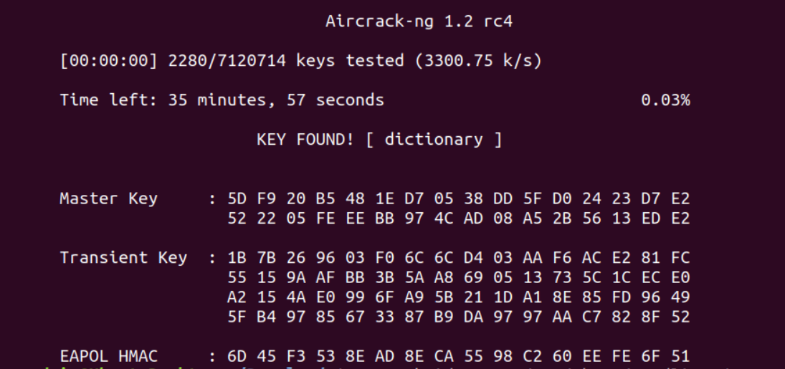

**Use the Dark Side's key to decrypt the wireless traffic in Wireshark.**  
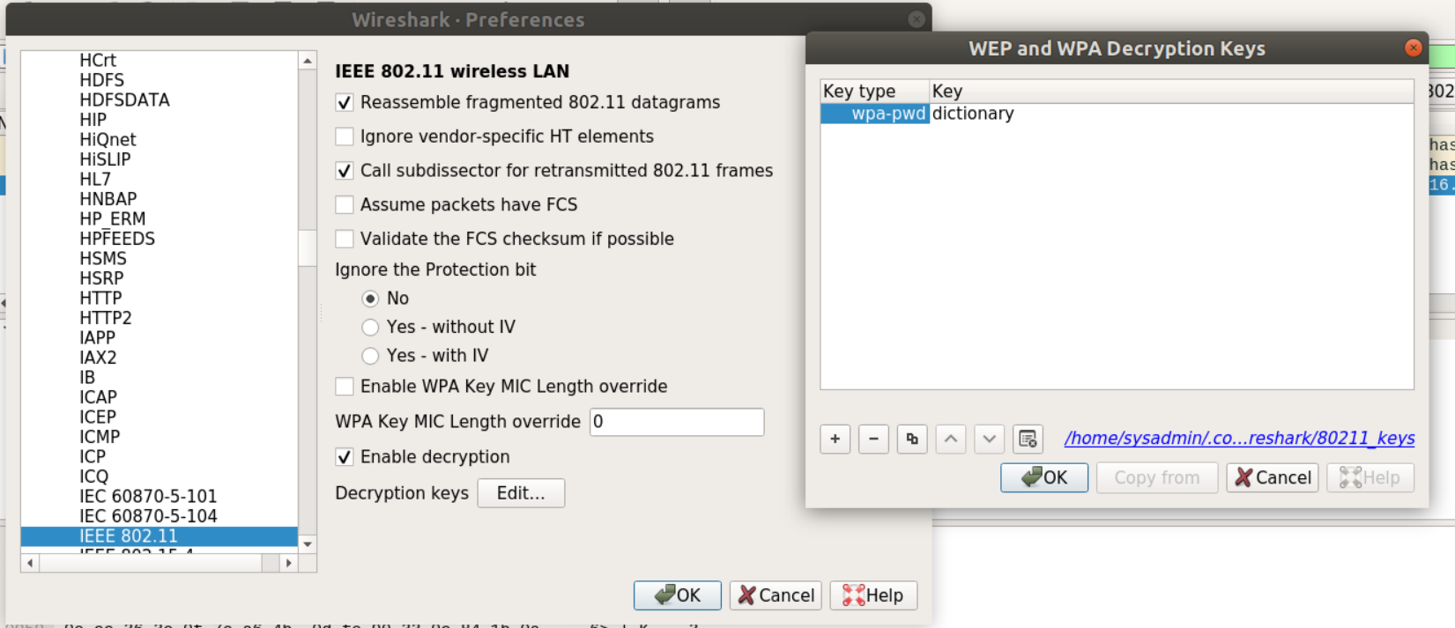

**Once you have decrypted the traffic, figure out the following Dark Side information:  
Host IP Addresses and MAC Addresses by looking at the decrypted ARP traffic.**  
**Document these IP and MAC Addresses, as the resistance will use these IP addresses to launch a retaliatory attack**.

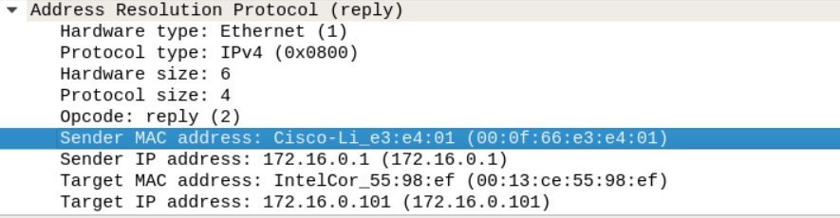

### **Mission 7**

View the DNS record from Mission #4.

The Resistance provided you with a hidden message in the TXT record, with several steps to follow.

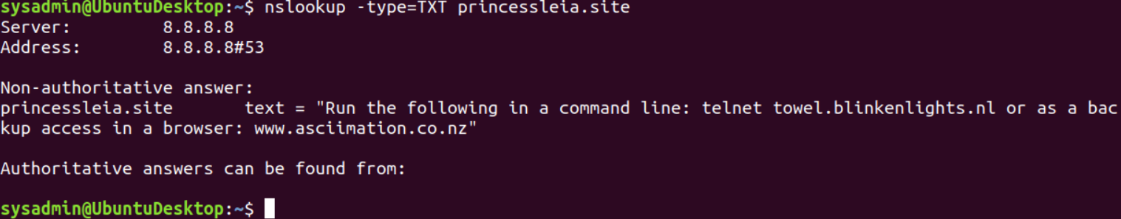

Follow the steps from the TXT record.  
**Note**: A backup option is provided in the TXT record (as a website) in case the main telnet site is unavailable

**Take a screenshot of the results.**sysadmin@UbuntuDesktop:~$ telnet towel.blinkenlights.nl worked on the command line but I could not stop it to take a screenshot. So I used the website www.asciimation.co.nz

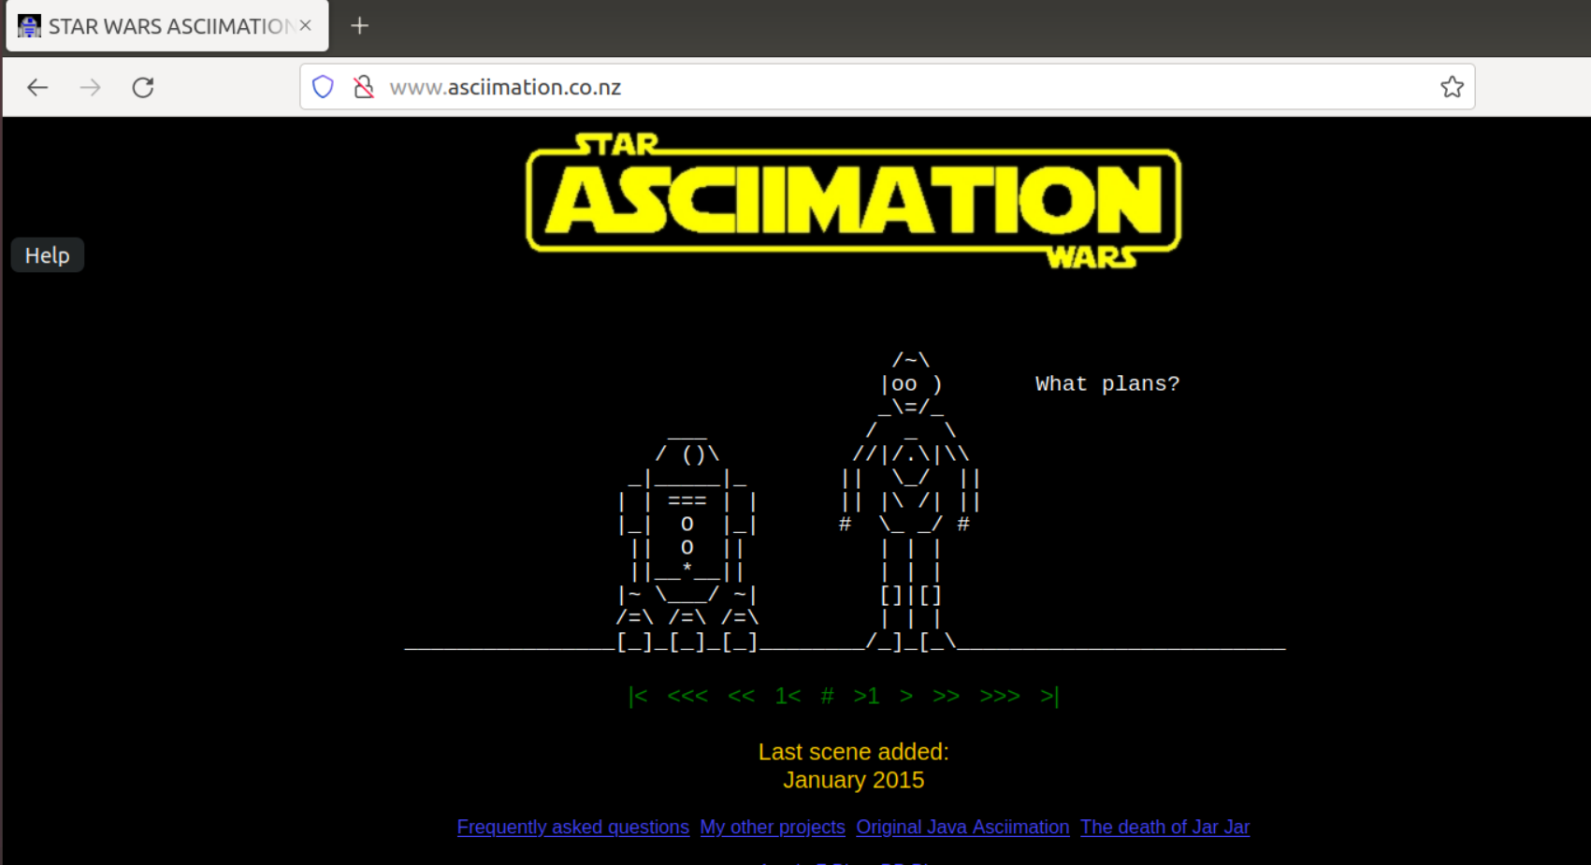

### **Conclusion**

* Submit your results and findings from every mission.
* Congratulations, you have completed your mission and saved the Galaxy!